Section 4:
I thought Role was the correct answer. After looking on AWS website, users can authenticate with password or keys
It is said in the course slides with roles that “there are no credentials associated with a role (password or access keys)”
https://docs.aws.amazon.com/IAM/latest/UserGuide/id_roles_common-scenarios.html
For more complex uses of roles, such as granting access to applications and services, or federated external users, you can call the AssumeRole API. This API call returns a set of temporary credentials that the application can use in subsequent API calls. Actions attempted with the temporary credentials have only the permissions granted by the associated role. An application doesn't have to "exit" the role the way a user in the console does; rather the application simply stops using the temporary credentials and resumes making calls with the original credentials.

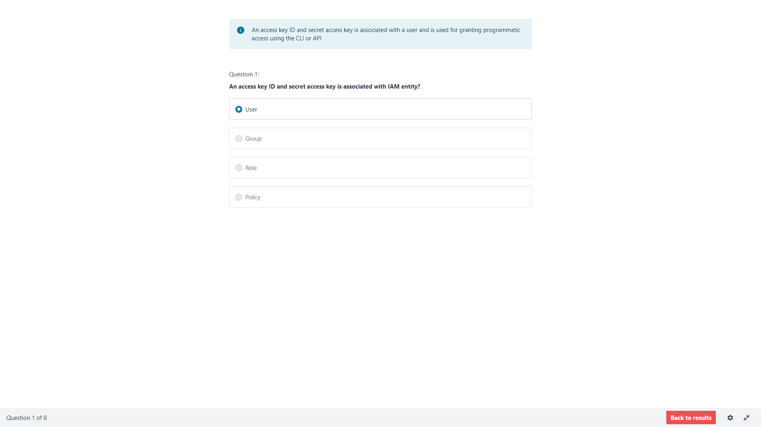

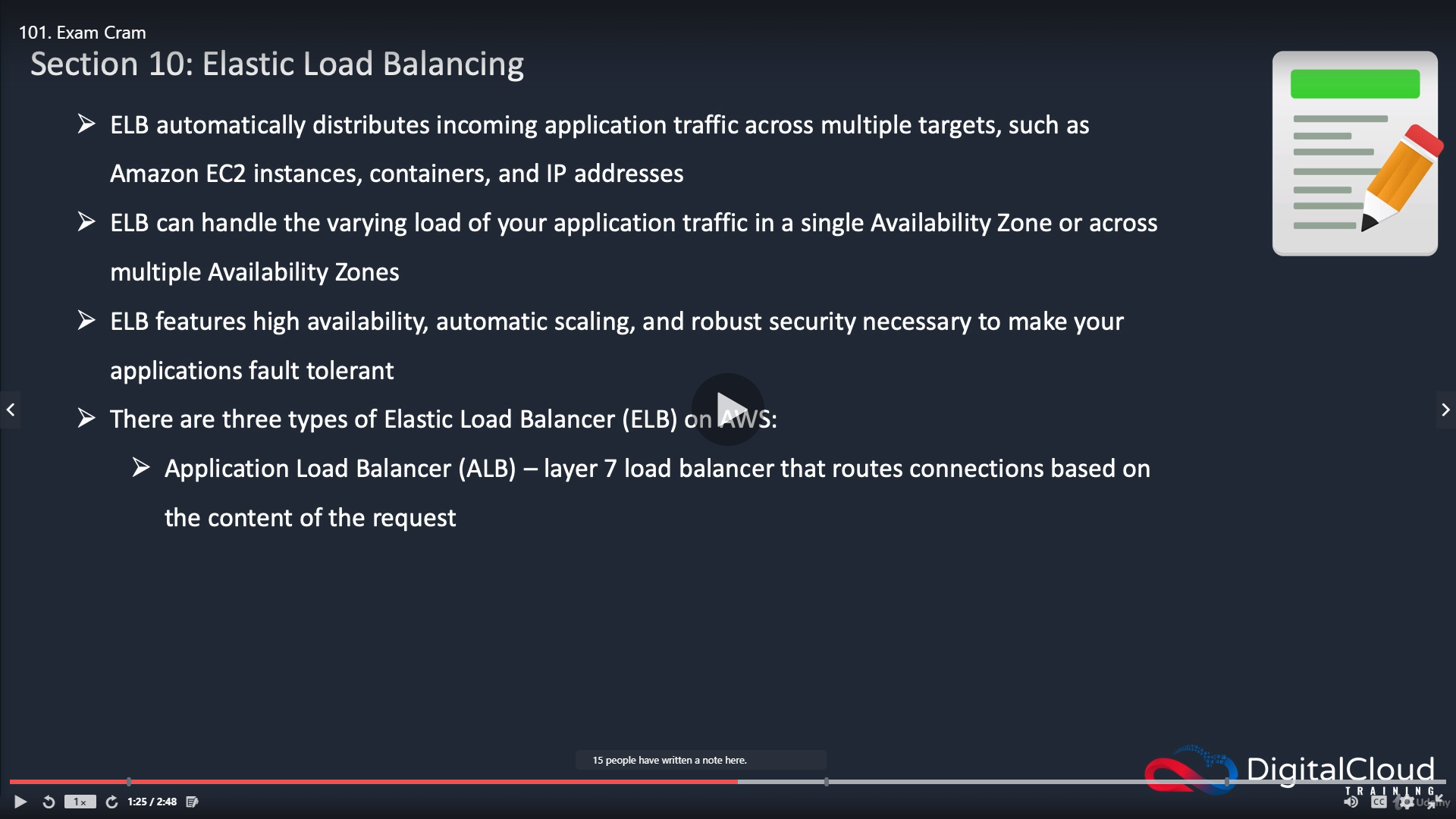
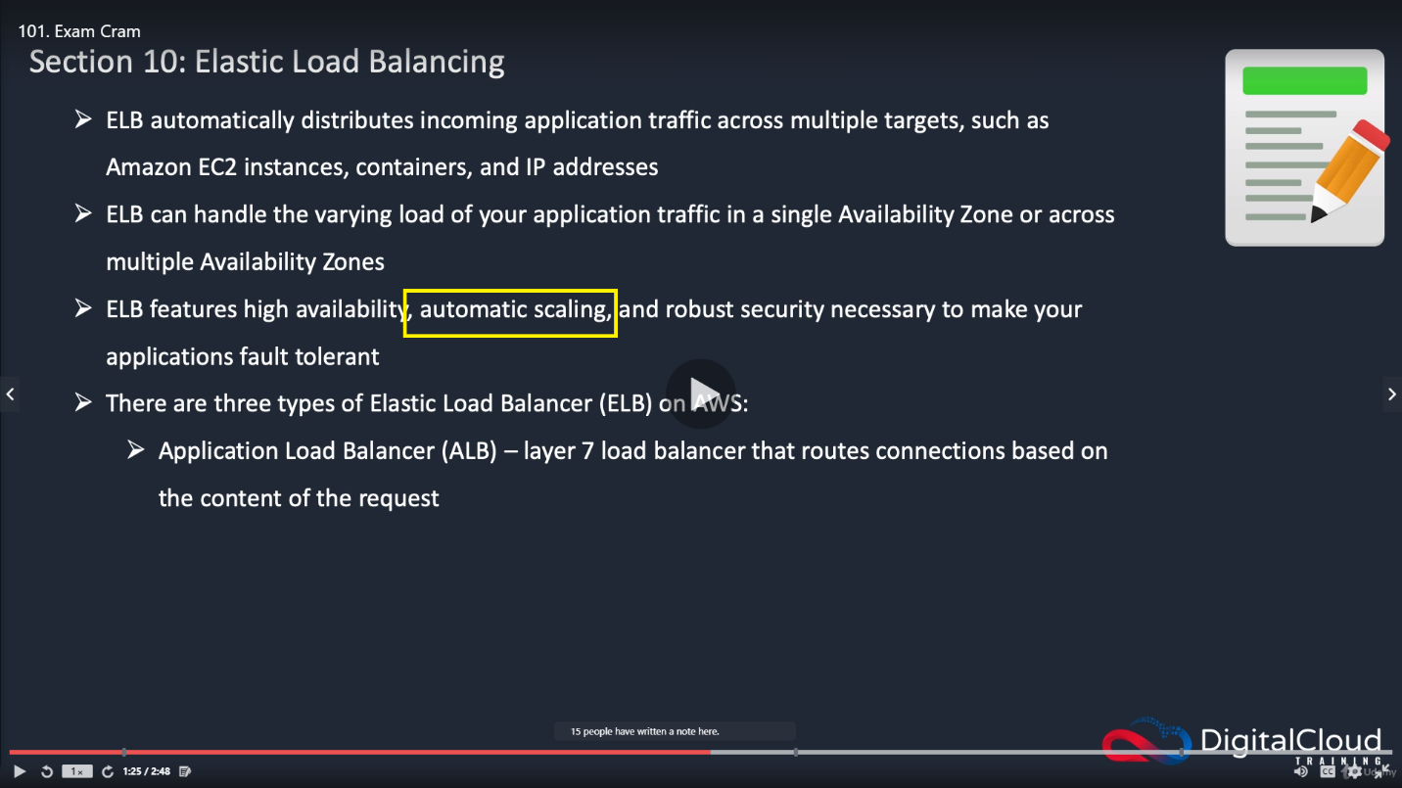

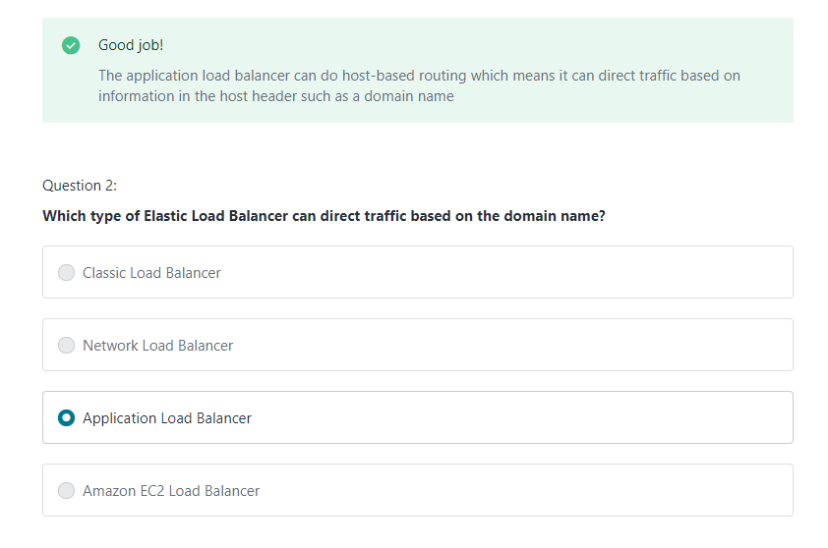
The thing here is the “Classic Load Balancer” can also direct traffic based on the domain name. It being depricated is a separate issue from its functionality.

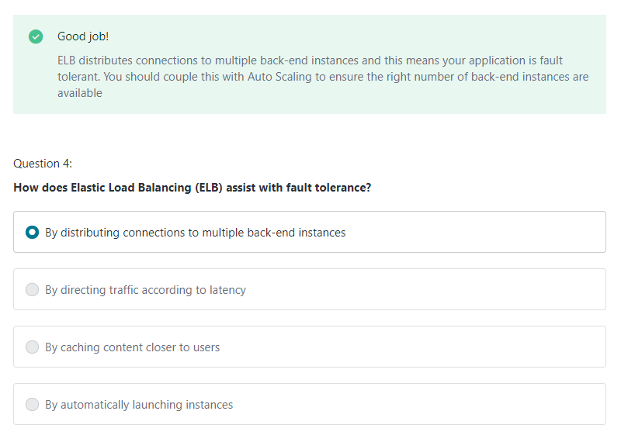

The argument against the second answer isn’t something I understand. The algorithm for load balancing could very much direct the incoming request to the services according to latency. (this could be interpreted as being either high or low latency since it is not specified) It could determine that the response from some instances in the availability group is longer than other instances and use that in its determination of what instance to use when a service request is made. (maybe this is where both are acceptable answers)

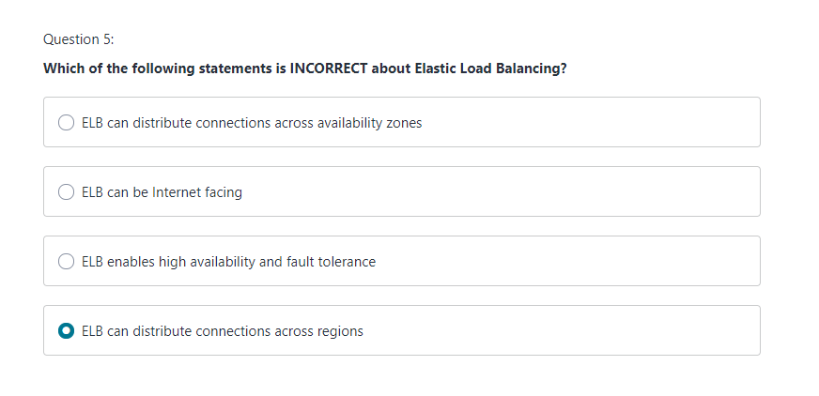
I can’t say I’m a fan of the term “connections”, for a couple reasons. One it isn’t a term that is used much in the lessons for the section or in the course either. Also, most AWS services are RESTful services (API calls are made to the services) so the idea of a connection doesn’t really exist, at least for the most part. It would be the same as saying the person making a request to google.com through a browser has made a “connection” to google. They made a request to google for a resource at google.com and got a response from google.com, as a result of the request made with them, and that response was handled in a browser. If I remember right, the HTTP protocol does have provisions for a “connection” between a client and the server it is sending the request to, but it doesn’t get used for a vast majority of requests.

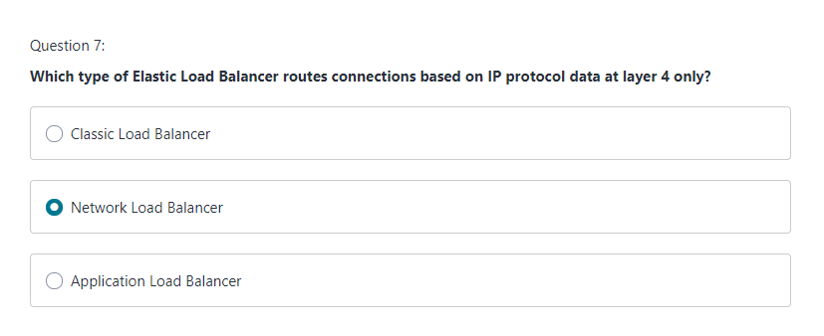
The thing here is the “Classic Load Balancer” can also direct traffic based on the domain name. It being depricated is a separate issue from its functionality.

Section 21 :: Architecting for the Cloud
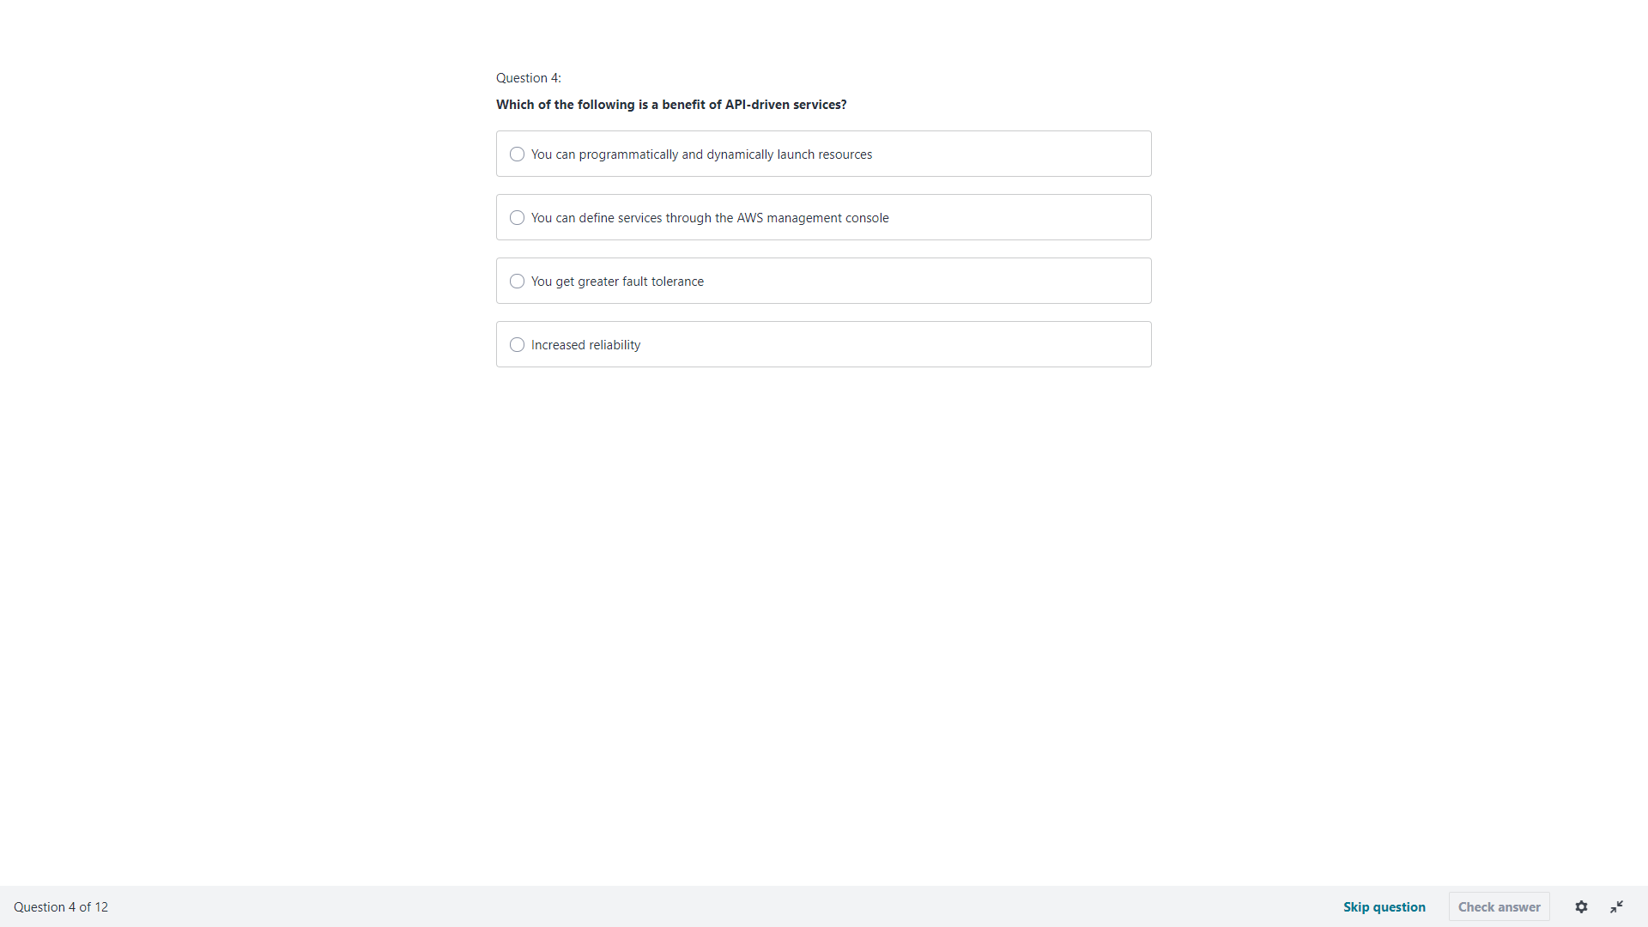
Are you really looking for the difference between “You get greater fault tolerance” and “Increased reliability”? If someone picks the “wrong” one, how will they know why their answer is wrong compared to the right answer? (the first one is the right answer, you can do the same thing with applications that are not services so I don’t understand why that would be the right answer)

Section 15 : AWS Billing and Pricing

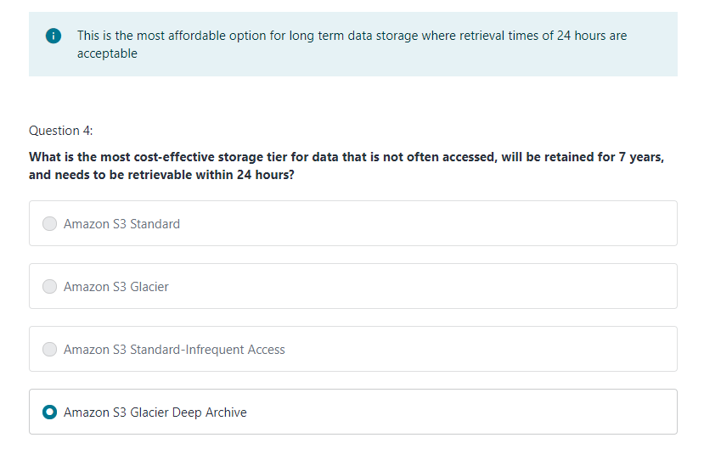

Amazon S3 Glacier Deep Archive is not mentioned in lesson 134 or lesson 136.

